|  |
| --- |
| Google Ad_Hours_Analysis_With_Python |
|  |
|  |
|  |

**Date : 22/06/2023**

|  |  |
| --- | --- |
| **Project Start Date - End Date** | * Start Date – 22 -06 -2023 * End Date – 22-06 2023 |
| **Objectives** | * To analyses how many people who clicked on the advertisement enrolled in our course * General exploratory analyses * General descriptive analyses |
| **Milestones accomplished the week of Start Date - End Date:** | * Descriptive analyses * Exploratory analyses * Classification of data with respect to term * DecisionTreeClassifier |
| **Milestones accomplished the week of Start Date - End Date** | * Data import * Data overview * Data preprocessing * Descriptive analysis. * linear regreesion * DecisionTreeClassifier. * Exploratory data analysis. * Main alogorithms * Correlations * Conclusion * Insights |
|  |  |
|  |  |
|  |  |

# **Contact Information**

This project is performed for educational purpose of under the guidance of Siddhivinayak Sir .

|  |  |
| --- | --- |
| **Project Manager**  Name : Siddhivinayak Phulwadkar  Mobile: 9028965955  Email: [siddhivinayakphulwadkar@gmail.com](mailto:siddhivinayakphulwadkar@gmail.com) | **Student Name**  Name : Veerbhadra Govind Lavharale  Mobile: 9607194266  Email: virbhadralavrale@gamil.com. |

# **Project Abstract**

The dataset is about showing … 1**. DATA IMPORT AND OVERVIEW.:- import data set by using pandas ,numpy seaboarn, by ploting use matpilot .pyplot. then overview the data how data big or small there is no null find** 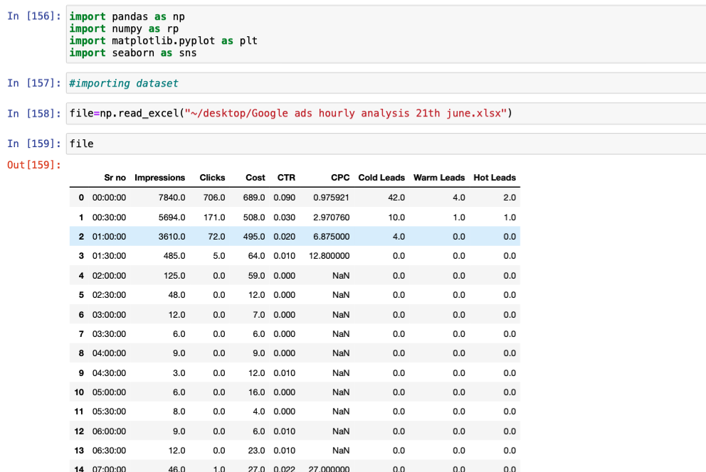

2**. DATA PREPROCESSING** :-

#check number of unique value from all data set

vs.isnull().sum()

#remove columns

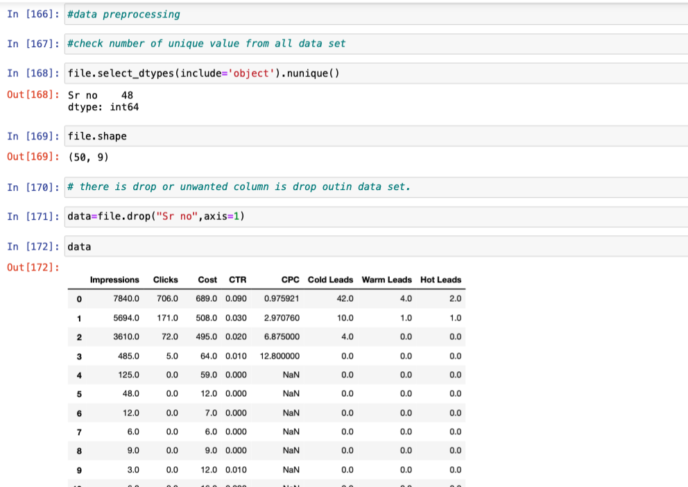

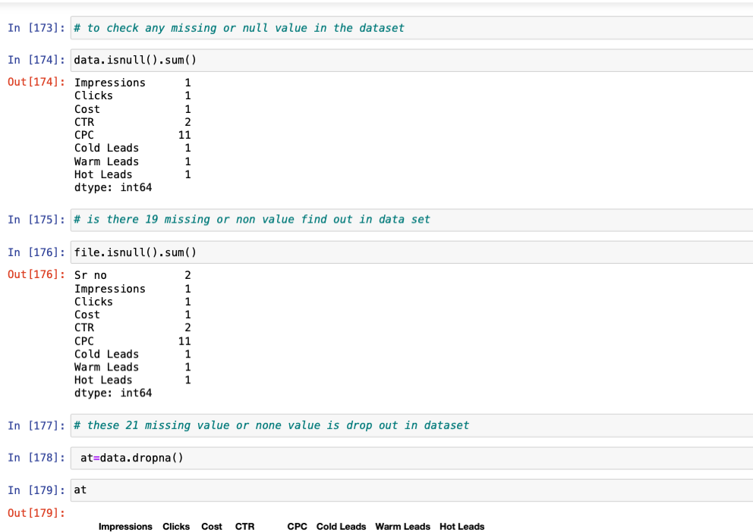

**3.DESCRIPTIVE ANALYSIS.:-**

**It describe the information about data set like its std .** **deviation nad mean ,max and count etc**

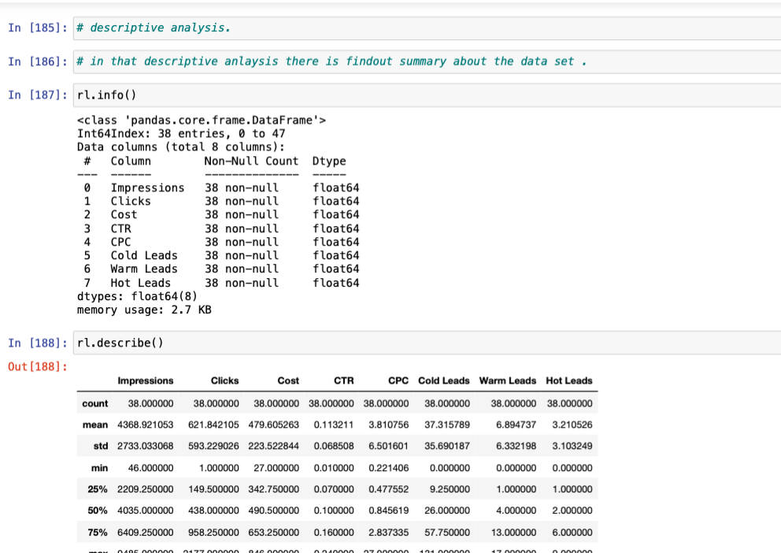

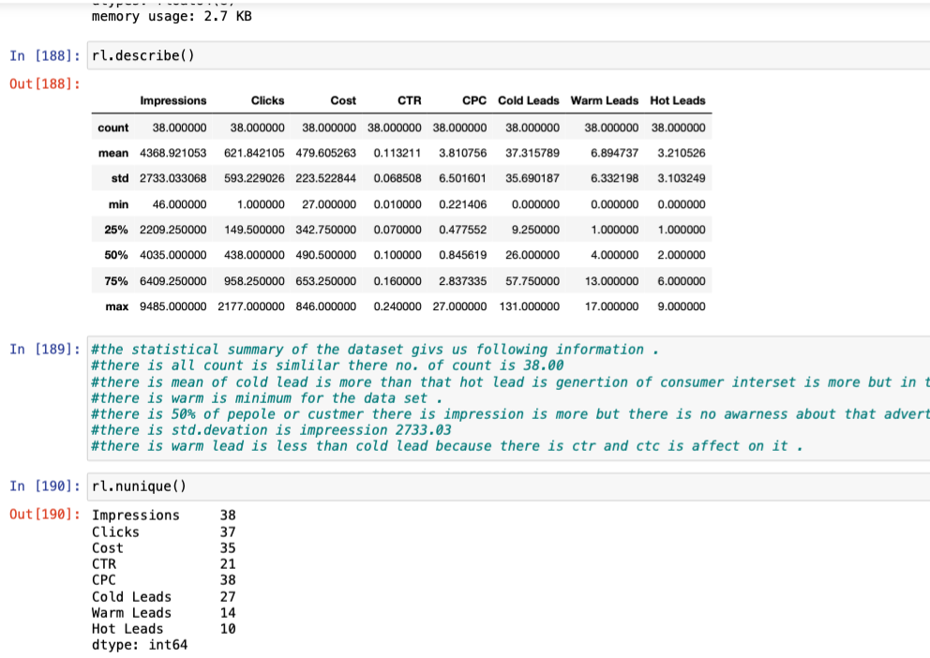

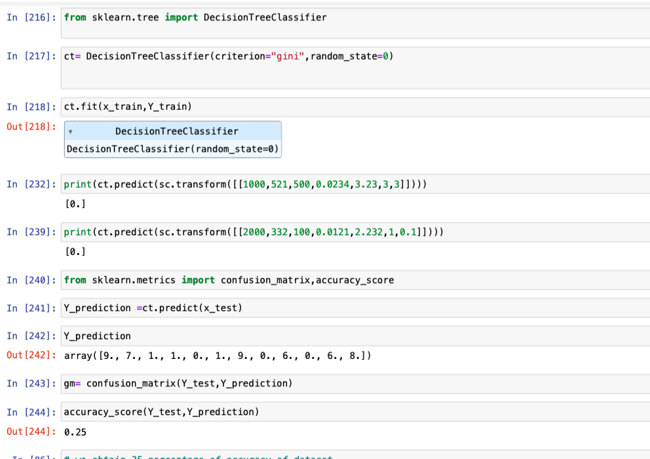

Descision Treeclassifier:-

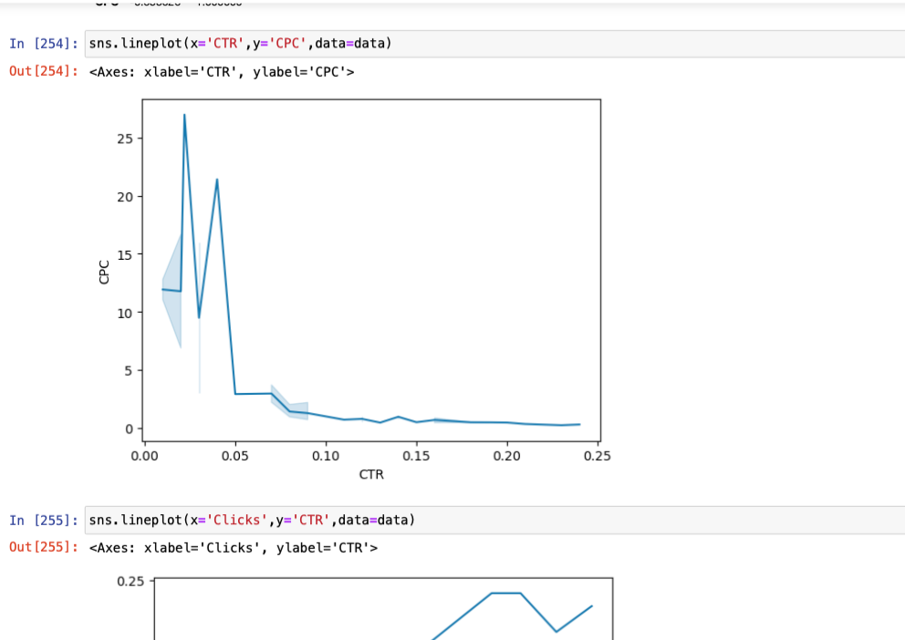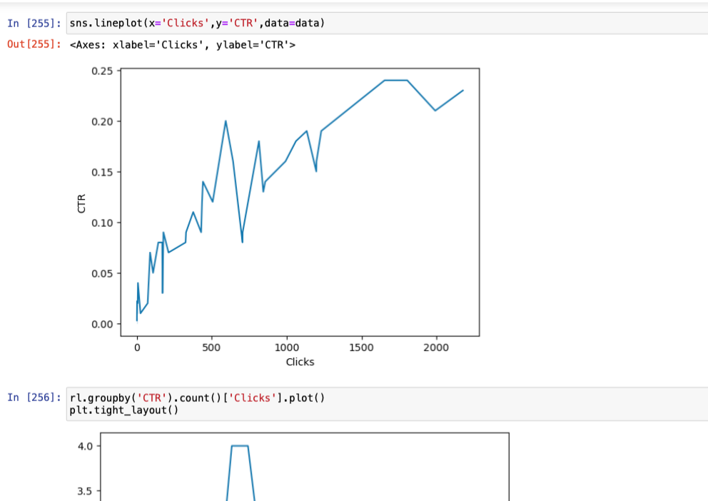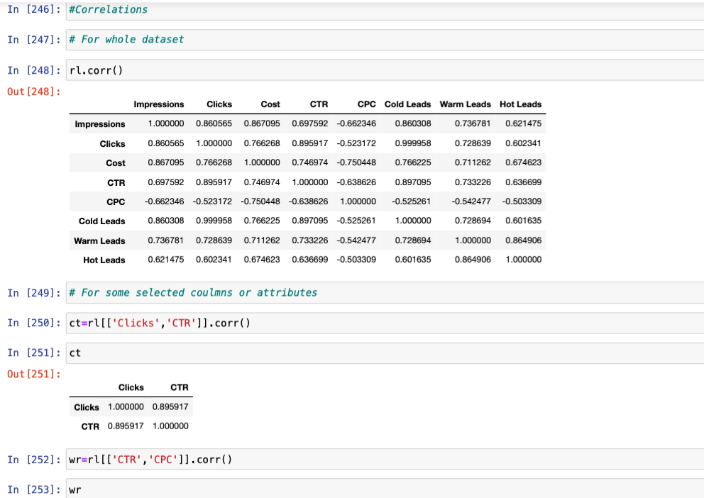

Exploratory data analysis.- Exploratory data analysis is an approach of analyzing data sets to summarize their main characteristics, often using statistical graphics and other data visualization methods. A statistical model can be used or not, but primarily EDA is for seeing what the data can tell us beyond the formal modeling or hypothesis testing task.

* Correlations
* Conclusion

Insights

Main Alogorithms

Insights

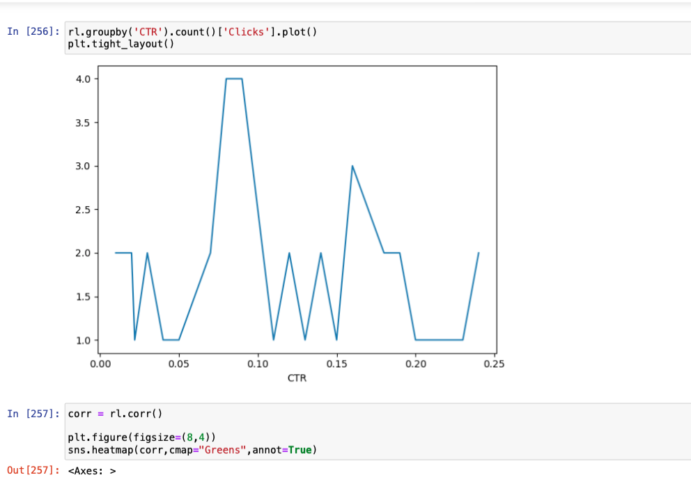

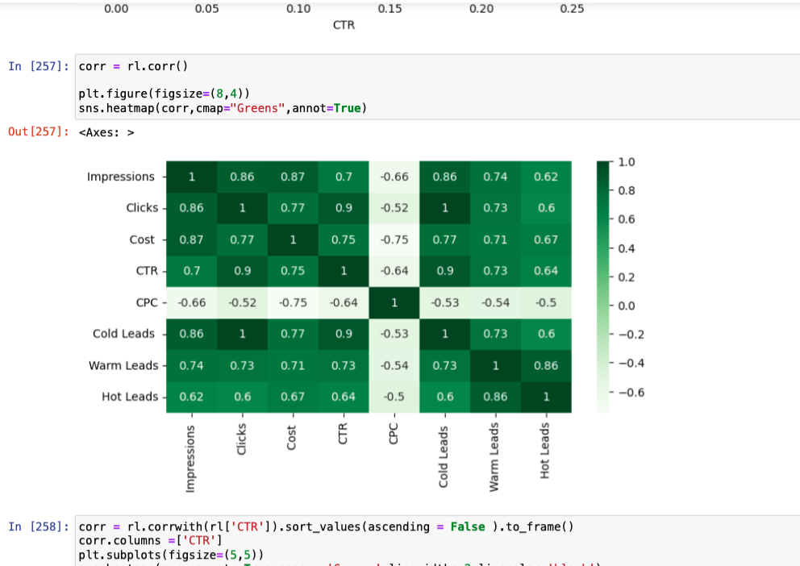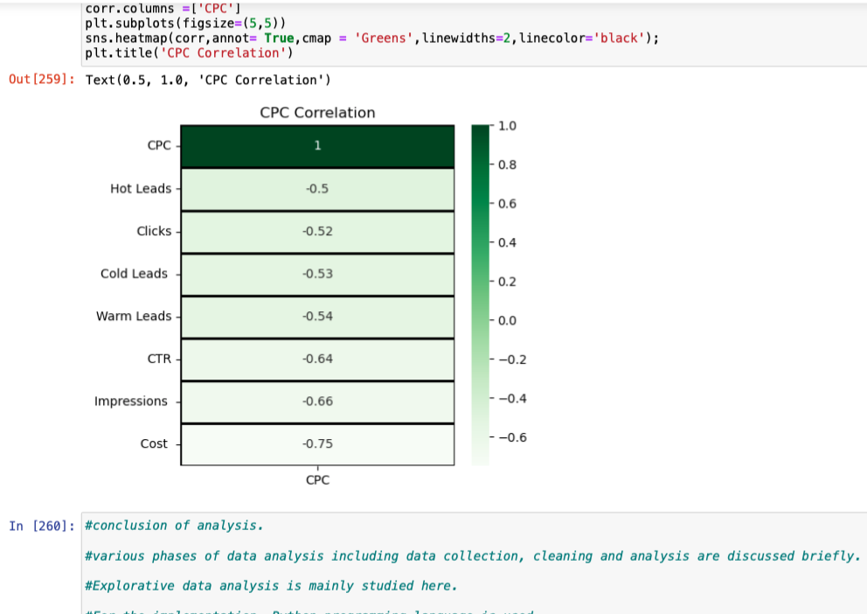

Correlations – relation between two variables .

**conclusion of analysis.**

#conclusion of analysis.

#various phases of data analysis including data collection, cleaning and analysis are discussed briefly.

#Explorative data analysis is mainly studied here.

#For the implementation, Python programming language is used.

#For detailed research, jupyter notebook is used. Different Python libraries and packages are introduced.

#We can see that the Impression ,Clicks and Sales units there are interrelation between them

# we can see that when clicks increase Sales also increase .

# The clicks had the best sales.

# the cost had more spend to advertisement in per clicks. i.e cpc.

# the cold leads had the more than hot lead there is little custemer see this adsvertisment.

# we can see that the DecisionTreeClassifier is used for accuaracy define in dataset.

#the statistical summary of the dataset givs us following information .

#there is all count is simlilar there no. of count is 38.00

#there is mean of cold lead is more than that hot lead is genertion of consumer interset is more but in that data there is less than cold lead .

#there is warm is minimum for the data set .

#there is 50% of pepole or custmer there is impression is more but there is no awarness about that advertisment.

#there is warm lead is less than cold lead because there is ctr and ctc is affect on it .

# In conclusion the provided data indicates that the ad campaign get a moderate level of explosure with substantail number of impression and reasonable number of clicks.

# the clicks through CTR suggests that ad was sometime or some what engageing .but there is room for improvement to increase user see and engagement.

#the cpc indicates that the campaign was relatively more cost ot cost effectively. in acquiring clicks.

# therefore number of leads generated , particularly in warm and hot leads is relatively low .

# suggest marketing head campagin may need further optimization to drive more conversions and improve lead quality .

# other awareness element or campaign elements to better resonate with the target audience and attract higher quality leads.

# to recommended to analyze the target audience, messaging or other campaign.

# to regularly monitoring, analysis and adjustments will be conduct to maximize advertisement is effective and achieve more benefit.

**Insights**

. In all about analysis dataset to inform that general marketing and how the people was aware about advertisement

# this advertisement was 21 th June.

# It main think that there was Wednesday is a working day .

# people mindset was to do workaholic or motivated

# that day they search or aware about courses

# some people was went house from office that time is about 12.am

# some people go to saw this particular ads but not click .

# to all dataset analysis there was impression was slightly peak but not click this ads .

# some people to aware this ads more information was find to click them this ads then this ads useful for this.

# those people want to sale this course.

# by the analysis is found that there is interrelation between CTR, and CPC of particular advertisement

# and to analysis of what is hot leads and cold and warm leads generation of particular advertisement

#for the analysis there is 0.25 accuracy of data is obtained it means that there is 25 % customer refer or see the this advertisement for course .

# i suggest to marketing head to increases ad. and display repeatbley for marketing and awareness purpose .

# on the time which choose the have you leads like warm , cold and and hot lead which will be consider.

# the campaign generated a total of impression is 4,368.92

# there were the clicks is 621.84

# the cost of overall campaign or advertisement was 479.61 that amount spent on advertising.

# the CTR is calculate 0.1132 and 11.32% is measures the effectiveness of dividing the no. of clicks and impression is 67.41 cost is generated.

#the advertise generated 37.32 cold leads they are potential customers shows there interest. but not yet engaged deeply with the course or service.

# warm lead generated 6.89

# hot lead generated 3.21

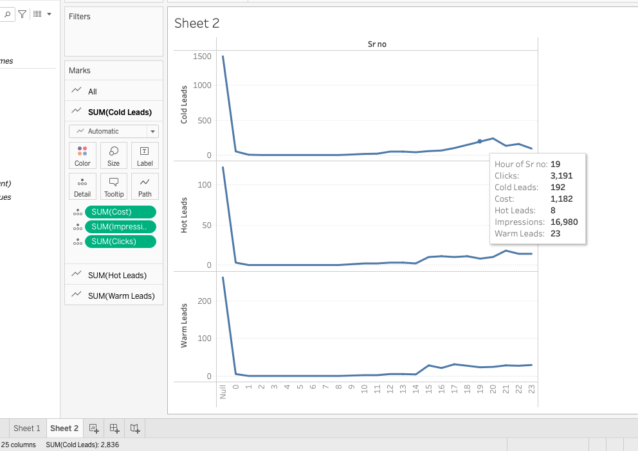

These insight which say that there is in day time CTR is increases continues. And CPC is low due to there is no customer sale low . I suggest marketing to study on CPC which is some time is low . this is overall analysis of 21th June google ads. some people to aware this ads more information was find to click them this ads then this ads useful for this.

# those people want to sale this course.

# by the analysis is found that there is interrelation between CTR, and CPC of particular advertisement .

# To Analysis of what is hot leads and cold and warm leads generation of particular advertisement

# for the analysis there is 0.25 accuracy of data is obtained it means that there is 25% customer refer or see the this advertisement for course.

# Based on the provided data, here are some insights and conclusions that can be drawn:

#Based on these insights, it appears that the ad campaign generated a moderate number of impressions and clicks.

# The CTR suggests that the ad was somewhat engaging, although there is room for improvement.

#The CPC indicates that the campaign was relatively cost-effective in acquiring clicks. However, the number of leads generated is relatively low, especially in the warm and hot categories, suggesting that the campaign may require further optimization to drive more conversions.

# Further analysis and adjustments to targeting, messaging, or other campaign elements may be necessary to improve lead quality and increase the overall effectiveness of the campaign.